AI Blog Nest – Generate High Quality blog content using AI

Govt arts college for women , krishnagiri

Team ID : SWTID-2026-3558
Team Size : 5
Team Leader : VIDHYA B
Team member : VIJAYA SRI S
Team member : VIJAYALAKSHMI V
Team member : VYSANATHY M
Team member : NANDHINI V

Introduction
Blog Nest is a full-stack blogging web application that allows users to create accounts, write and publish blog posts, and engage with other users' content through comments and likes. The platform is designed to be simple, fast, and easy to use for both casual writers and regular readers.
The core goals of the project are to:
- Provide a clean, distraction-free space for users to write and publish articles.
- Allow readers to discover content through categories, tags, and search.
- Support user engagement through comments, likes, and follows.
- Give administrators tools to moderate content and manage the platform.
Blog Nest is built using a modern web stack — a React front end, a Node.js/Express back end, and a MongoDB database — following a typical three-tier architecture that separates presentation, business logic, and data storage.
Note: this report assumes a React / Node.js / MongoDB stack. If your project uses a different stack, this section and the diagrams below can be updated accordingly.

Software Requirements
Operating System: Windows 10/11, macOS, or Linux (supports cross-platform operations).
Node.js (v16 or above): Runtime ecosystem running server logic and routing infrastructure.
npm (v8 or above): Node package manager to control operational dependencies.
Express.js: Lightweight routing web framework to construct backend RESTful entry points.
MongoDB: Document NoSQL engine storing users, posts, categories, comments, and analytics metrics.
Postman: API verification toolkit to assert schema validation responses across administrative route shields.
Code Editor: Visual Studio Code or similar IDE environment.

Hardware Requirements
Processor: Intel Core i5 (8th Gen or above) / AMD Ryzen 5 or equivalent.
RAM: 8 GB minimum (16 GB recommended for concurrent instances of MongoDB, processing layers, and execution nodes).
Storage: 1 GB of available disk workspace.

Project architecture
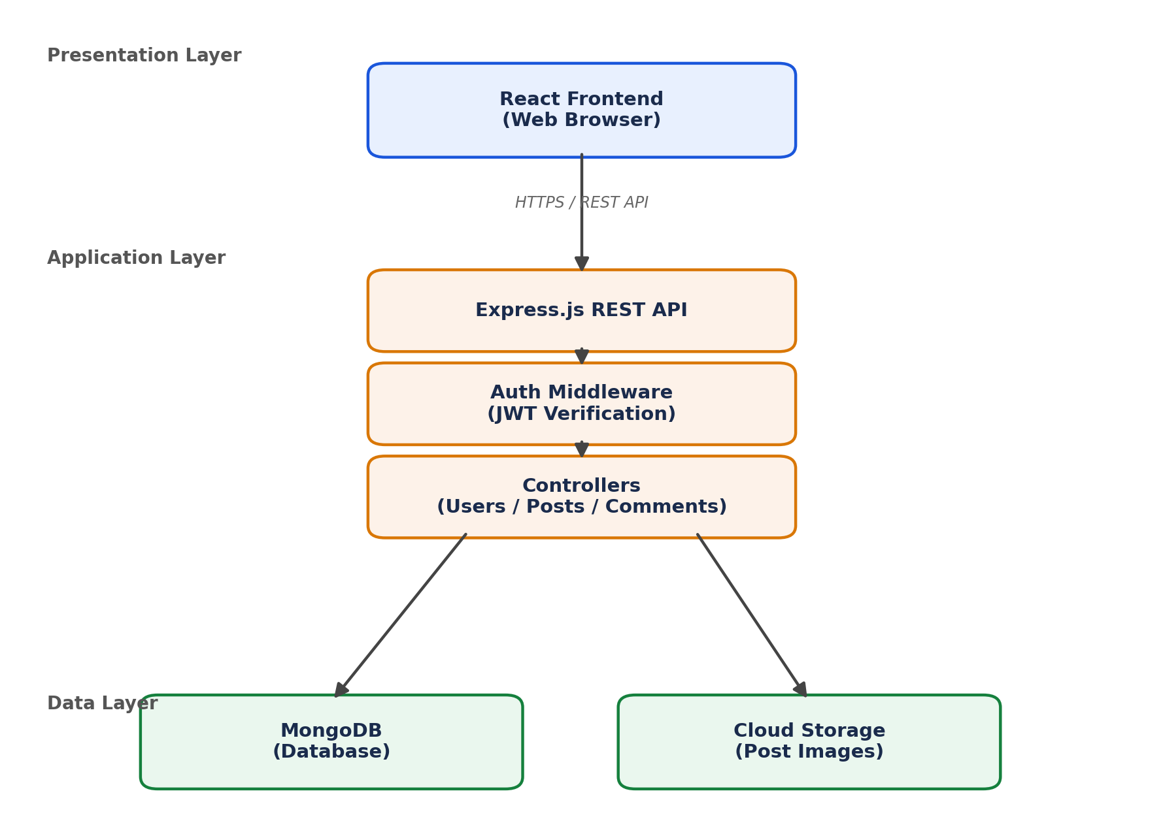
Figure 1: Blog Nest system architecture

Key Components
Component | Responsibility
React Frontend | Renders pages, manages UI state, calls backend APIs
Express REST API | Routes incoming requests to the right controller
Auth Middleware | Validates JWT tokens, protects private routes
Controllers | Contain business logic for users, posts, comments, likes
MongoDB | Persistent storage for all application data

ER Diagram
The data model centers on Users who write Posts, which can receive Comments and Likes, and are organized under Categories.
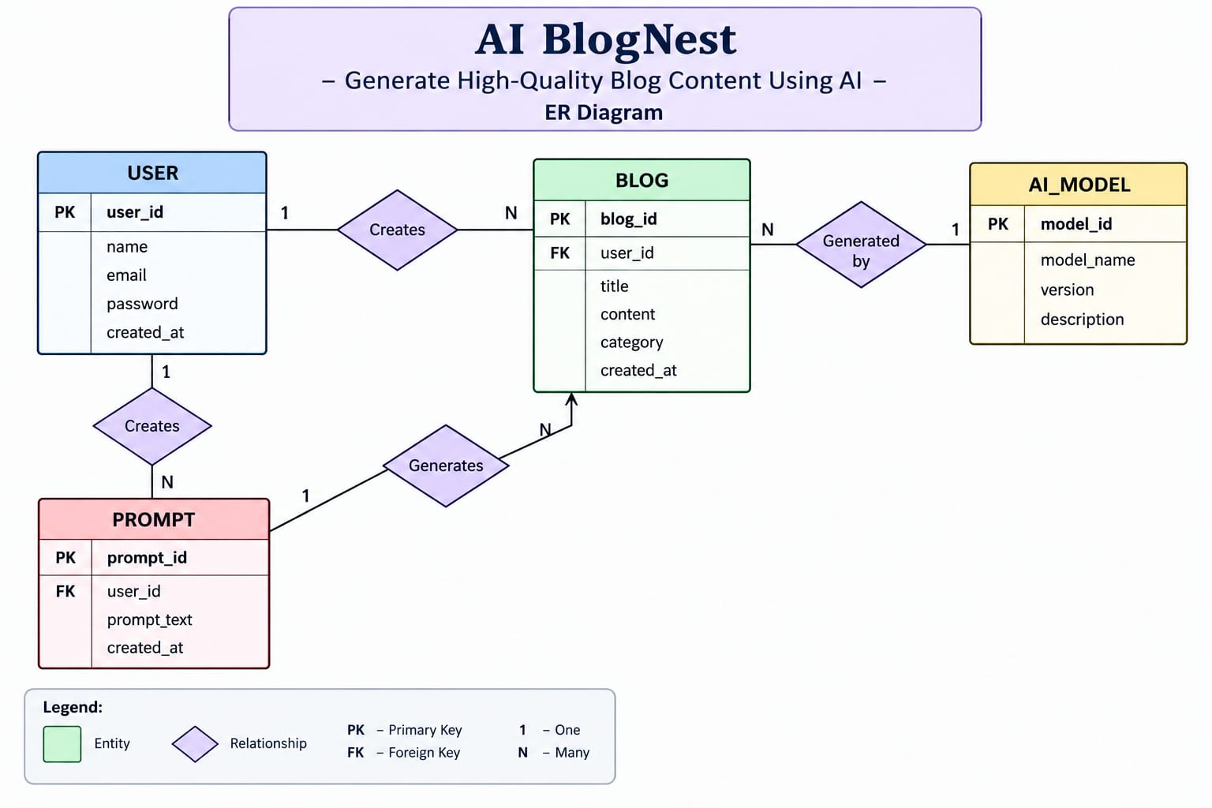
Figure 2: Entity-Relationship diagram
User Entity
- _id (Primary Key - ObjectId)
- name (String, Required)
- email (String, Required, Unique)
- password (String, Hashed, Required)
- role (String, Default: "reader")
Post Entity
- _id (Primary Key - ObjectId)
- userID (Foreign Key referencing User Collection)
- name (String, Required - represents Title)
- photo (Object/String pathway link)
- message (String - Core content body)
- likes (Number, Default: 0)
- timestamps (True)

Relationship Summary
- A User can write many Posts, Comments, and Likes (1-to-many).
- A Post belongs to one User (author) and one Category, but can have many Comments and Likes.
- A Category can classify many Posts.

Development Team Roles

Role | Responsibilities
Frontend developer | Builds UI components, handles state management, integrates with backend APIs, ensures responsive design
Backend Developer | Designs REST APIs, implements authentication, writes business logic, manages database schema
Database Administrator | Designs the schema/ER model, optimizes queries, manages backups and data integrity.
UI/UX Designer | Designs wireframes and mockups, ensures a consistent and usable interface

Key Features
- Role-Based Route Guarding: Strict token processing blocks unauthorized tiers from modifying core settings.
- CRUD Blog Execution Engine: Complete schema management over content definitions, status states, and asset assignment paths.
- Categorization System: Native tag indices facilitate filtering and querying for enhanced discoverability.
- Comment Moderation Logic: Protected entry points for updating moderation flags (approved, pending, spam).
- Sanitization Safeguards: Payload parameter sanitation prevents XSS vectors and NoSQL parameter manipulation injections.
- I-Driven Blog Generation Pipeline: Integrates external Large Language Model (LLM) abstractions and context-aware prompt templates to synthesize full-length, structured blog posts from high-level thematic inputs.
- Intelligent Content Summarization Engine: Leverages semantic compression layers to parse extensive article payloads, dynamically generating concise abstracts and automated metadata summaries.

Project setup and configuration
Creating project folder

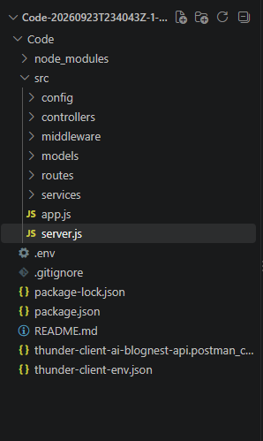
Server setup(npm init)

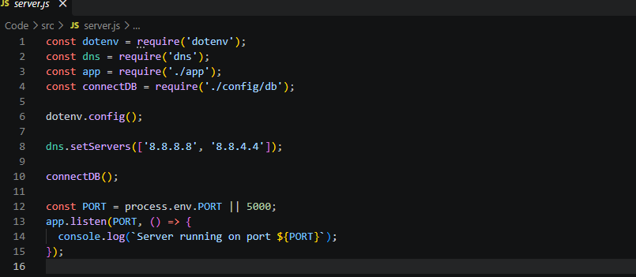

App.js
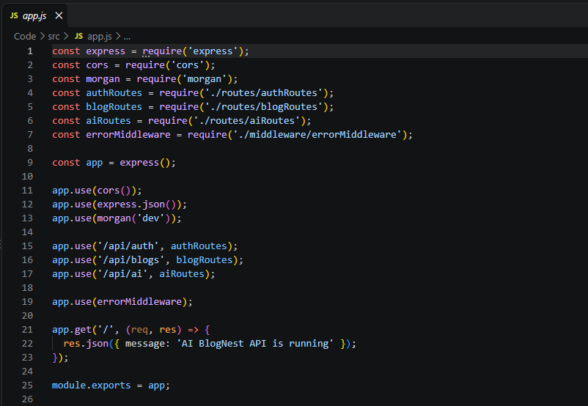
API TESTING
Mongodb connection:
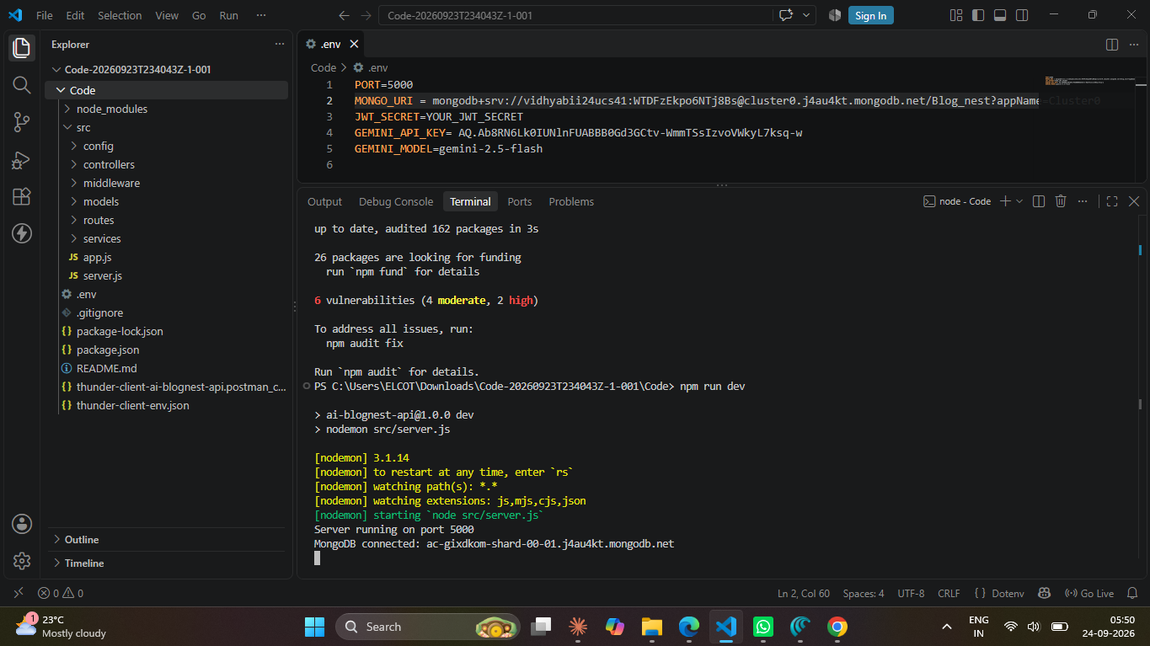

User registration:
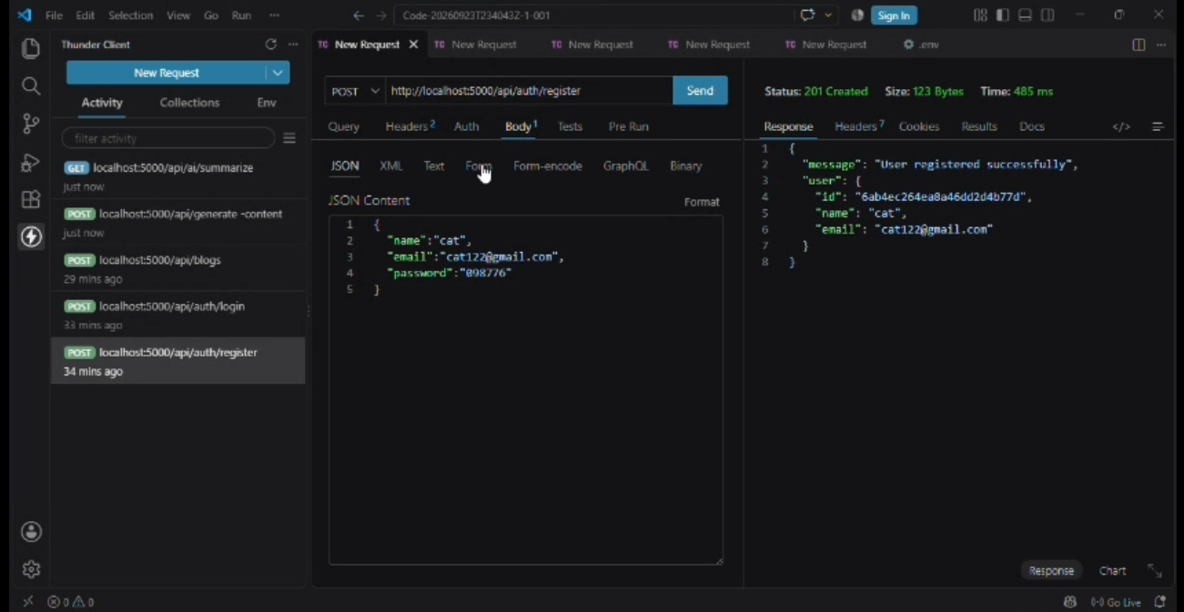
User Login:
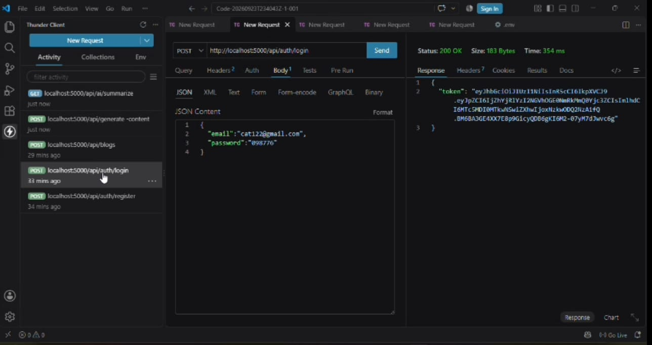
Create Blogs:
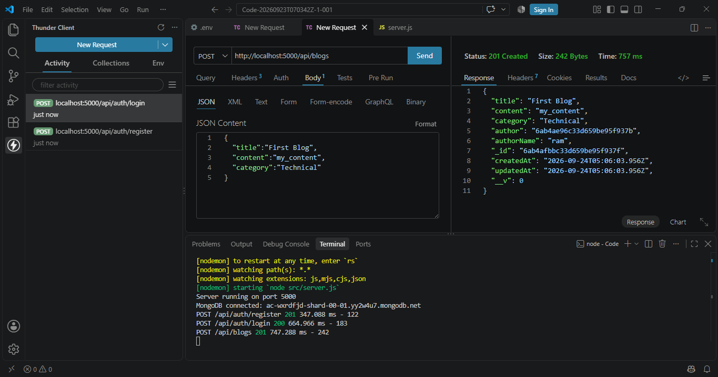
Fetch Blogs:
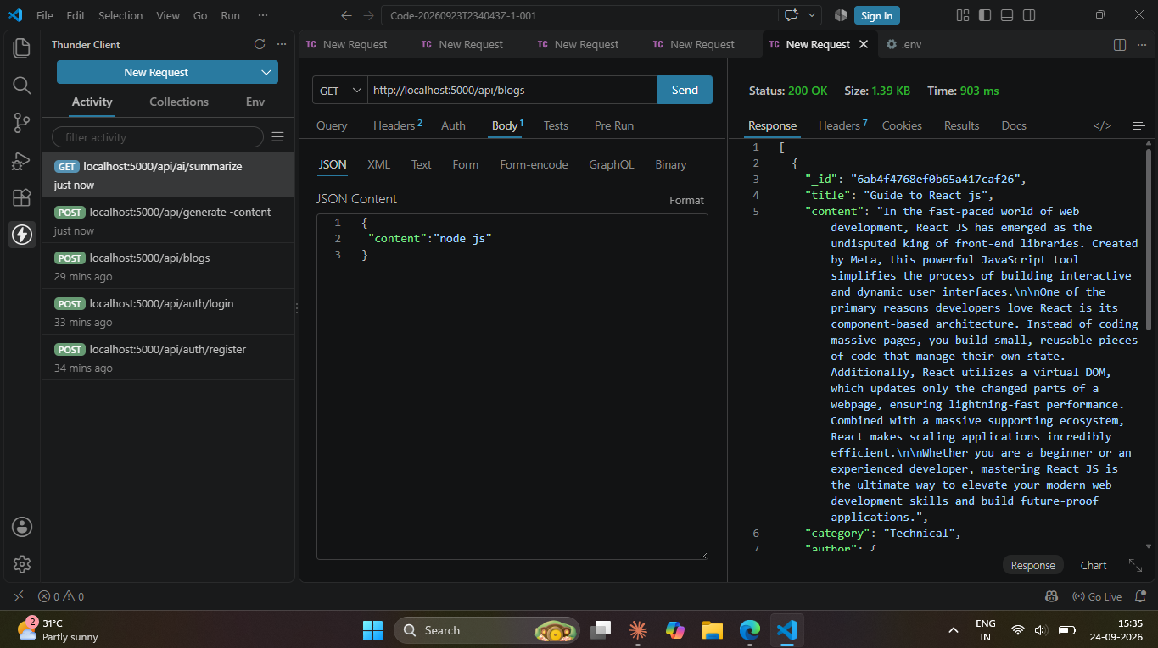
Generate AI Blogs:
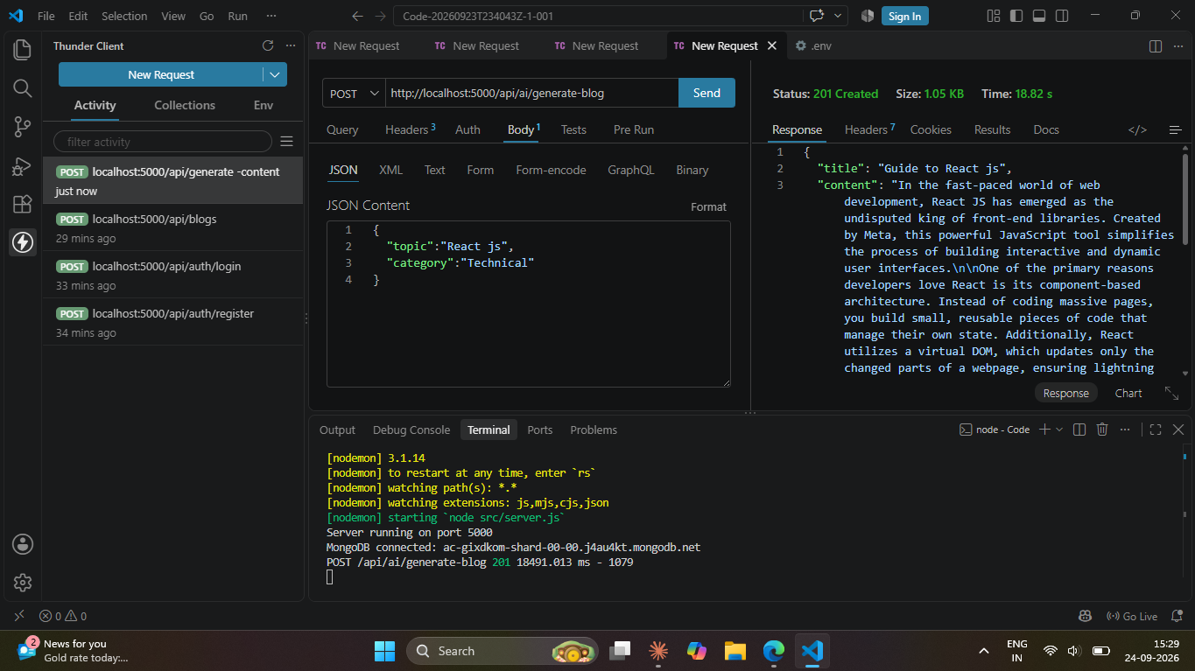
Summarize Blogs:
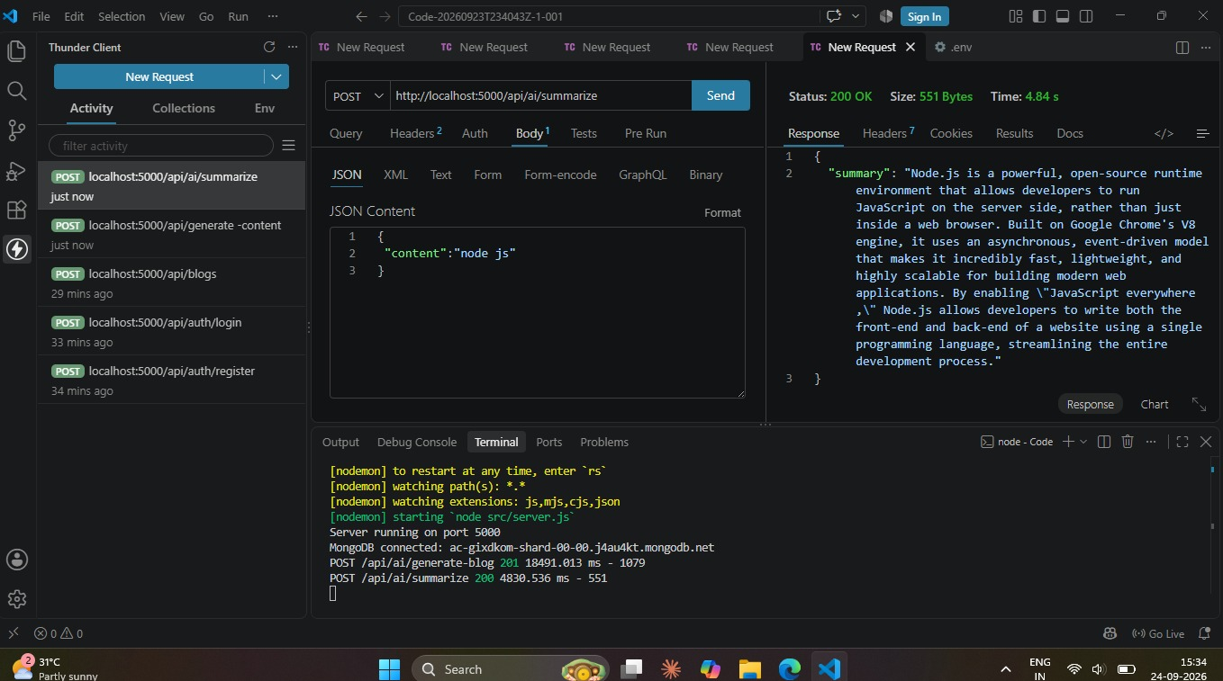
Demo video:
API Testing:

